Day One -DPS HQ

Keynote Address by Colonel Melissa Zebley, Delaware State Police

Colonel Zebley leads a department of over 1,000 employes, including 730 sworn officers. She is the first woman in the history of the agency to be appointed to the highest position in the state police. Of the 730 sworn officers she leads, 97 of them are women.

In July 2020, Zebley was named colonel in the DSP by Gov. John Carney after being nominated by her predecessor, former State Police Col. Nathaniel McQueen Jr., who is now Secretary of the Delaware Department of Safety & Homeland Security.

At the beginning of her career, in July 1992, she was assigned to Troop 6 in Prices Corner, and through the years has held positions including drill instructor, sergeant assigned to Troop 1 in Penny Hill, patrol supervisor, public information officer and later director of that department, lieutenant, captain, major, operations officer and lieutenant colonel.

A 1991 graduate of the University of Delaware, where she earned a bachelor’s degree, Zebley also graduated from the Northwestern University School of Police Staff & Command in 2000 and earned a master’s degree in 2003 from Wilmington University. She is a 2008 graduate of the 235th Session of the Federal Bureau of Investigation National Academy, and has been a Wilmington University adjunct instructor and a program assistant for the Criminal Justice program.

Edited Version:

Keynote Address: Colonel Melissa ZebleyColonel Zebley leads the Delaware State Police, which has 1,000 employees, including 730 sworn officers. She is the first woman in the history of the agency to be appointed to the highest position in the state police. Of the 730 sworn officers she leads, 97 of them are women. Zebley was named colonel of the DSP in July 2020 by Gov. John Carney after being nominated by her predecessor, former DSP Col. Nathaniel McQueen Jr., who is now Secretary of the Delaware Department of Safety & Homeland Security.At the start of her career in July 1992, she was assigned to Troop 6 in Prices Corner, and has since served as a drill instructor, sergeant assigned to Troop 1 in Penny Hill, patrol supervisor, public information officer, lieutenant, captain, major, operations officer, and lieutenant colonel. Zebley holds a bachelor’s degree from the University of Delaware and a master’s degree from Wilmington University. She also graduated from the Northwestern University School of Police Staff & Command in 2000, and from the 235th Session of the Federal Bureau of Investigation National Academy in 2008. She has been a Wilmington University adjunct instructor and a program assistant for the Criminal Justice program.

Expert Panel:

Panelists:

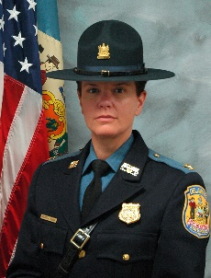

Colonel Melissa Zebley

Delaware State Police

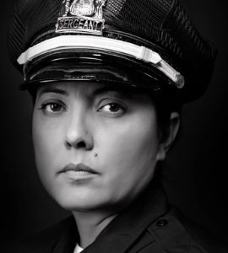

Sergeant Yanira Scarlett

Des Moines PD

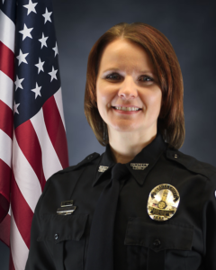

Assistant Chief Carrie Jacobs

Iowa State University Police Department

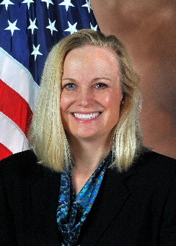

Special Agent Holly Witt

Iowa Division of Criminal Investigation- Major Crimes Unit

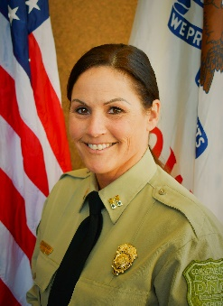

Captain Deborah Vitko

Iowa Department of Natural Resources

Case Review

The Murder of Angela Bradbury

Presented by Special Agent Scott Reger and DOI Analyst Nikki Roberts

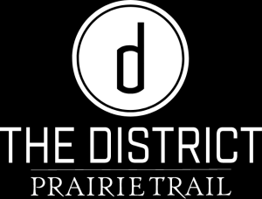

After Hours

Day 2- Camp Dodge

